**Southeast Raleigh Elementary School Student & Family Handbook**

**2022-2023**



Home of the Lions!

1436 Rock Quarry Road

Raleigh, North Carolina 27610

(919) 694-8444

(919) 589-6440 (fax)

[www.wcpss.net/southeastraleighes](https://www.wcpss.net/southeastraleighes)

**School hours: 8:00 am - 3:00 pm**

***“A Community Responsive School that strives to cultivate an Atmosphere of Awesomeness!”***

.

We would like to give a special thanks to our Community Partners:

*SE Raleigh YMCA of the Triangle*

*Southeast Raleigh Promise*

“Alone **we can do** so little; **together we can do** so much.” - Helen Keller

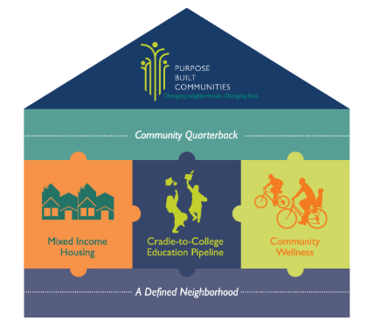

**Wake County Public Schools, YMCA of the Triangle and Southeast Raleigh Promise, are partnering to create a school that is a central part of a holistic approach to neighborhood revitalization surrounding the Rock Quarry Road Corridor. As the 16th Purpose Built Community in the Nation, Southeast Raleigh Promise combines neighborhood revitalization strategies with a cradle-to-career pipeline of support for children and their families.**

Please review the contents of this parent and student guide as it pertains to the procedures we will uphold at SRES. If you have any questions or need additional assistance, you may call us at 919-694-8444. Every school creates their own procedures for maintaining building safety and security, as well as operational and instructional procedures; therefore, we encourage you to know how Southeast Raleigh Elementary operates.

**Our vision & mission are synonymous with Wake County Public Schools’ vision & mission**

**Vision:** Southeast Raleigh Elementary students will become leaders, excel academically, reach their potential and be transformers within their community.

**Mission:** Southeast Raleigh Elementary will provide a relevant and engaging education and will graduate students who are collaborative, creative, effective communicators, and critical thinkers.

**Values:** Southeast Raleigh Elementary community values equity, relationships, and a growth mindset through innovation, empowerment, and collaboration and standards of excellence. Our goals will be developed by our leadership team and will include academic as well as behavior/social/emotional goals. As we learn our students and disaggregate the data that comes with each of them, we will be able to create goals specific to the areas in which improvement is needed. 

Southeast Raleigh Elementary School Identity

Stronger Together

At Southeast Raleigh Elementary School, we take PRIDE in everything we do!

Partnerships

Partnering with organizations such as the YMCA and Southeast Raleigh Promise to help enrich our community.

Relationships

Cultivating positive and authentic relationships amongst stakeholders through positivity project, community efforts and the mindset that all students deserve an equitable learning opportunity.

Identifying Individual Student Needs

Using multi-tier systems of support to provide rigorous instruction to meet the needs of each learner.

Developing Core Instruction

Grade level teams and instructional support staff partner together to ensure that students receive rigorous and developmentally appropriate instruction.

Engaging Families and Community

As a community responsive school, we are always putting the needs of the community first. We strive to find creative, and effective ways to bridge the gap between the community and schools. We desire that our family’s partner with the school by joining school-based teams to collaborate and problem solve to meet the needs of our students. Additionally, we want our families to feel comfortable supporting the school in whatever way they feel is best, as long as all families DO SOMETHING! It takes the village!

TOP 5 Priority Procedures Guardians Must Know FIRST! (Subsequent procedures are in ABC order)

1. SAFETY AND SECURITY PROCEDURES: 

BUILDING ENTRY: The school building is locked all day with the only exception being the school doors leading to carpool during arrival and dismissal. However, they are monitored by a staff member. In order to gain entry into the office after arrival, all visitors must ring the doorbell located on the left side wall of the front entryway, state purpose of visit and Show Government issued ID. Once you gain access into the main office, you will be directed to sign in at the kiosk. You will receive a visitors’ label to stick on the outside of your attire. This label must be visible for all staff and students to see. Visitors found without visitors’ stickers will be directed to the main office. All visitors must sign out in the main office after each visit. Students and staff are directed to not open any outside doors for any visitors and must exit through the main office.

2. VISITORS & VOLUNTEERS:

For safety reasons, Wake County Public School System Policy states that all school visitors must report to the office and sign in when entering the building. A visitor badge must be obtained when you sign in.



**1) Volunteers**-All volunteers must be cleared by WCPSS volunteer registration. (See volunteer description below)

**2) Parent conferences**

**3) Lunch with your child**

**4) Classroom event(s)**

While we welcome visitors into our school, spontaneous (and non-spontaneous) classroom visits and observations are not allowed unless you have communicated with the classroom teacher first. A classroom visit or observation must be already scheduled. The Southeast Raleigh staff are committed to ensuring and protecting the valuable instructional day from disruptions. Visitors will need to sign in when you arrive and out upon leaving the building.

VOLUNTEERS:

We welcome volunteers to our campus to support our instructional program (non-teaching roles) however, your visit must be pre-arranged. All volunteers must sign-in at arrival and sign-out after duties are completed. In order to volunteer in the capacity of supporting field trips or in-class events, you will need to be deemed **CLEARED** by the WCPSS volunteer system. This system conducts a criminal background check on all applicants. Applications can only be completed in our Media Center or at another WCPSS school. Clearance can take up to three weeks. You will need your driver’s license and social security number to complete the volunteer registration. People who visit for single or random occasions such as awards assemblies may sign in as visitors, not volunteers. If you were cleared during the 2021-2022 school year, you will need to complete a reactivation form. The process takes about 5-10 minutes, and we encourage you to complete the form during the first few weeks of school. The data manager, Ms. White, will reach out to inform you on whether you are cleared or not cleared to volunteer at the school.

**For the safety of our students, all non-Wake County Public School personnel will be required to sign-in at the main office and questioned regarding the purpose of their visit, in order to obtain a nametag.** Any person not wearing a nametag or badge will be re-directed to the front office.

3. SCHOOL HOURS:

The school campus is officially open at 8:00 AM and students will be marked tardy after the 8:30 AM tardy bell. The staff is not legally "on duty" until this time. Students should NOT arrive prior to this time because there will be no adult supervision. Dismissal will begin promptly at 3:00 PM daily. There will be no office dismissal after 2:30 PM daily because it causes disruption of the dismissal procedures. This is not inclusive of the YMCA before and after-school care.

4. STUDENT BIRTHDAYS:

 We DO NOT have birthday parties at school during instructional time. However, birthday snacks (PREFERABLY HEALTHY SNACKS) can be shared in the cafeteria during scheduled lunch times, or a fun physical activity can be shared at recess. Snacks must be from commercial suppliers and not homemade. Due to students with food allergies, it is required that classroom teachers are notified prior to bringing in any healthy snacks. Please be respectful of staff members on duty in the cafeteria and be mindful of their responsibilities. Additionally, if bringing in a healthy snack, please bring in only one type of snack. The following items are not permitted at all: party favors, decorations, hats, goody bags, and balloons. These items are potential safety hazards to students.



5. SCHOOL TO HOME COMMUNICATION:

Our school communicates through a variety of platforms; however, the following platforms only a few of those platforms are crucial in helping you stay connected with school curriculum and happenings.

**1. School’s website** (<https://www.wcpss.net/southeastraleighes> ) Our school website has a calendar for upcoming events and is populated for the entire year at the beginning of the year with only a few updates throughout the school year.

**2. Principal’s Message** – Our school Principal Mrs. Fenner sends messages through the WCPSS School Messenger System platform each week, typically on Thursdays. The messages are communicated in a variety of ways including texts, emails, and voice calls. All parents/guardians should include their emails and phone numbers in PowerSchool to ensure that the School Messenger message is received. If your number changes, please let your child’s teacher know. The School Messenger system is a tool for proactively contacting large numbers of parents via the telephone, email and or text. This system also keeps parents informed of their child's attendance by delivering nightly messages to the homes of those students who are marked absent. 

**3. Talking Points -** Please sign up for our Talking Points app for frequent and consistent home to school communication primarily between you and your child’s teacher.

4. Our **website and social media sites** are also good ways to stay connected. Our Facebook and Twitter pages showcase a variety of WCPSS and Southeast Raleigh happenings!



**School Twitter**: @SERaleighES

**School Facebook Page**: https://www.facebook.com/Sreslions

**5.** Classroom Teachers send home emails, texts (through Talking Points and Canvas App), folders, and school agendas.

**6.** Agendas: K-5 students are expected to utilize school agendas to also communicate with families. Each agenda is $3.00 and should be purchased by Sept. 14, 2022.

**ATTENDANCE:**

Regular school attendance is necessary for academic success. Students are expected to be present daily unless they are ill or there is an emergency that prevents him/her from attending. We prioritize and value instructional time and need every minute to provide students with quality instruction. For that reason, we ask that you ensure your child arrives at school on time and that you refrain from early check-out (before 2:30) unless it is an emergency or for a scheduled appointment.

TARDIES:

Being prompt to school is very important. Instruction begins daily at 8:30 AM; however, students are encouraged to be in his/her seat by 8:15 AM. This allows students time to prepare for the day by eating breakfast, visiting the media center, and organizing his/her supplies. Students not in their assigned classroom by the instructional bell **(8:30 AM)** are considered tardy and must be checked in at the front office by a parent/guardian. They will need to pick up a class admittance slip before going to their classroom. Students are considered absent if they arrive at school after **12:30 PM** or leave prior to this time.

ABSENCES:

On time, daily attendance is crucial for student success. However, we recognize that there are times when a child must be absent from school. According to WCPSS School Board Policy 6103, an electronic or handwritten note from the parent/guardian must be presented to the teacher within 2 days of when the student returns to school after being absent. If the note is NOT received within the 2-day period, the absence will be recorded as “unexcused.” Notes should state the reason for the absence, the date(s) of absence, and a parent signature. You only need to call the front office if your child will be absent for more than three consecutive days.

ABSENCES are coded EXCUSED for the following reasons:

* Illness or injury which makes the student physically unable to attend school
* Isolation ordered by the State Board of Health or the Wake County Health Department
* Death in family
* Medical, dental, or other appointment with a health care provider for the student
* Court when a student is under subpoena
* Religious observation, as suggested by the religion of the students or the student’s parents
* Participation in a valid educational opportunity, such as travel with prior approval, as documented on the “Request for Excused Absence for Educational Reasons” form.

**EXCUSED EDUCATIONAL ABSENCES:**

To request an excused absence for special educational experiences, an excuse form must be submitted to the principal for approval at least two weeks prior to the educational absence. Please note that family trips/vacations are not considered educational trips, although they might have some educational value. These types of trips do not equate to the curriculum provided by our highly qualified staff. Educational Request for Leave Forms are available online at www.wcpss.net or in the main office.

**BEFORE AND AFTER SCHOOL:**

The Southeast Raleigh Family YMCA is pleased to offer Before School and Afterschool Care onsite at Southeast Raleigh Elementary School. Before school is an entertaining and structured morning program. They provide fun, loving staff to play and encourage your children. Most activities are held in the cafeteria and/or gym. They have a variety of games and challenges to play such as cards, board games, puzzles, and crafts. The Program runs from 7:00 am - 8:00 am each morning. After school is a safe, fun alternative to hanging out at home each afternoon! They fill the afternoons with gym and field games, arts & crafts, STEM activities, homework incentives, assemblies, and much more! The After School Program runs from 3:10 pm- 6:00 p.m. each school day; this includes scheduled early release days (1:00 pm- 6:00 pm), which are covered with the program cost. Teacher Workdays and Holiday Care is provided on-site at the YMCA. These days are sold separately.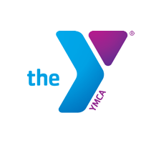

If you would like information on after-school care, please contact:

**Rodney McCormick** - Afterschool Coordinator for Southeast Raleigh YMCA

Phone: 919.838.7185 / email: Rodney.McCormick@ymcatriangle.org

The Southeast Raleigh Family YMCA and Southeast Raleigh Promise have partnered with Southeast Raleigh Elementary to provide academic enrichment and intervention support to our students as an academic extension of our instructional school day. This program is called **Club ROAR**. Club ROAR will operate on Tuesdays, Wednesdays, and Thursdays each week during the hours of 3:30-5:30pm.

**Bus Transportation is provided**. If you are interested in your child being a part of the academic extension program, **Club ROAR**, please contact Mr. Clive Edwards (assistant principal) at cledwards@wcpss.net.

**BUS TRANSPORTATION:**

Wake County Public School System provides safe and reliable bus transportation. School transportation services are a privilege. Students must observe the procedures established by the bus drivers at all times to ensure their safety. Students not complying with the bus safety procedures may have his/her privileges revoked. Bus riders must ride to and from school on the bus to which the WCPSS transportation department has assigned them. Students shall board and leave the bus only at their designated bus stop. Students are not permitted to ride a different bus home or have non bus-riders board the bus. Parents can follow the bus routes by downloading the ***Here Comes the Bus app***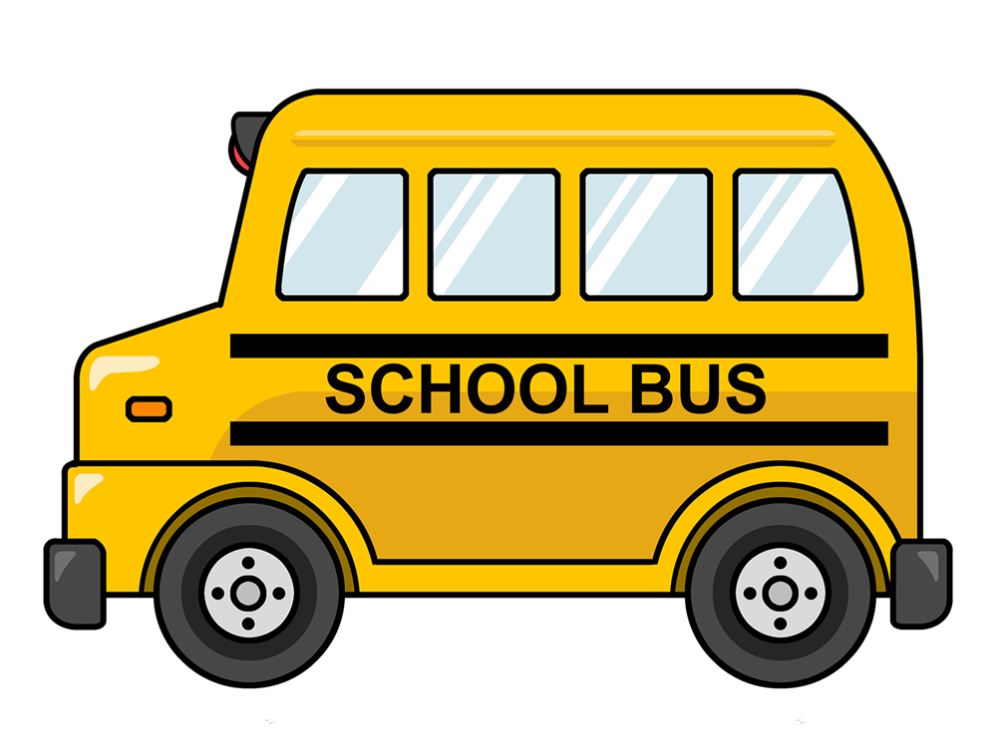.

(Click on link for) [Additional Transportation Information](https://www.wcpss.net/Page/53041)

**FOOD SERVICES:**

**ALL students attending Southeast Raleigh Elementary School this year will be able to receive school breakfast and lunch at no cost (including students that would otherwise pay for their meals).** School breakfast makes good sense! Every day, students are offered meals that include servings of fruit, whole grain-rich items, and low fat or fat free milk. School breakfasts are nutritionally well balanced and follow standards backed by the best science available. In addition to the no-cost and nutritional benefits, school breakfast also provides an ideal solution for families with hectic schedules that need some flexibility. Students may eat breakfast at school every school day or occasionally as a convenient alternative. It also gives students an opportunity to enjoy a morning meal with their friends.

Al la carte items such as milk, ice cream and cookies are available at an additional cost. To purchase these items, create an account for your child at MySchoolBucks.com. Once your account is established, you can check balances and fund the account anytime from your computer or Smartphone. If you prefer, you may also send in a check or cash only. Make sure that the funds are in a sealed envelope with your child’s name, student ID number, and the purpose for the funds. In addition, include your student’s ID number on the check.

We strongly encourage parents to have lunch with their children during the school year. An alternative eating area will be provided for you to eat with your child(ren). If you are bringing lunch for your child from outside of the school, you may only bring food for him/her and not any other student(s). Please inform your child’s teacher in advance so that they may make the proper arrangements.

|  |  |  |  |  |
| --- | --- | --- | --- | --- |
| 2022 - 2023 MEAL PRICES | | | | |
|  | SRES Students 2022-2033 SY | WCPSS  Paid “Full” Price | WCPSS Reduced Price | Adults |
| Breakfast | Free | $1.50 | Free | al la carte |
| Lunch | Free | $3.00 | .40 | al la carte |

Information on school meals can be found on the Child Nutrition Services website at www.wcpss.net/school-meals.

**Please contact our cafeteria manager, Adina Midgett, for more information at (919) 694-8660 Ext. 26852**



**CARPOOL PROCEDURES:**

Families are asked to follow the signage that will direct you around to the carpool/bus loop lanes. All families are required to have a carpool tag visible in the windshield. Carpool tags can be signed out from the office. Cars should stay to the left of traffic. Please stop at the stop signs and wait to be directed around to the side entrance of the building. Drivers should remain in their cars to aid in the flow of traffic. Carpoolers will need to pause before reentering traffic to ensure that buses have a clear pathway.

Please enter the Southeast Raleigh Elementary School Campus from Rock Quarry Road, passing the YMCA section of the campus. We ask that all visitors, volunteers, staff, and families enter the building through the main entrance so that they can be greeted and authorized by our school reception staff. This includes after-school events. Graphical user interface, application, Word

**CHANGE OF ADDRESS OR PHONE NUMBER:**

Parents are asked to provide a new proof of residence with any change in address or phone numbers so that we have accurate, up-to-date information for all students. In order for your address to be changed in the WCPSS system, please also provide the school office with a copy of your current utility bill showing your new information. All parents must give a phone number (home, work, mobile, etc.) where they can be reached during the school day in the event of an emergency.

**CHARACTER DEVELOPMENT:**

**At Southeast Raleigh ES,** all students are expected to follow our below **PRIDE** Expectations.

**DISCIPLINE:**

Maintaining a safe, orderly environment for our students is an important part of providing a quality education. Every situation will be investigated thoroughly and handled in an appropriate manner. We will continue to empower our students to build strong relationships, to understand, appreciate, and exemplify the PRIDE character strengths. Please note: Bullying, harassment bullying, and harassment are unacceptable behaviors that will be immediately addressed. Bullying and harassment include any physical act, threatening communication, or pattern of gestures or communications that places a student in actual and reasonable fear of harm or is certain to create a hostile environment. Bullying and harassing behavior includes, but is not limited to, behaviors motivated by the victim’s race, ethnicity, sex, sexual orientation, pregnancy, gender identity, religion, age or disability. If bullying or harassment is suspected, parents should contact the school for help. Parents and students also can share safety concerns via the WCPSS Tip Line, 919-856-1911. Please see the Board Policy regarding Prohibition Against Discrimination, Harassment and Bullying.

**DRILLS: FIRE/TORNADO/LOCKDOWN:**

Every precaution is taken to ensure the safety of your child during school hours. Therefore, monthly fire drills and periodic severe weather drills and lockdown drills are performed throughout the year.

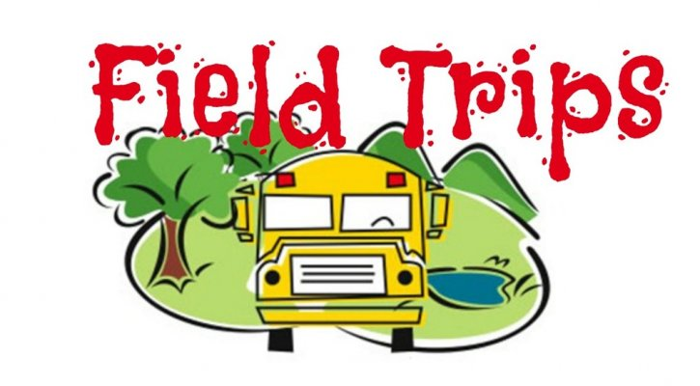

**FIELD TRIPS:**

Current educational philosophy recognizes the advantage of using the total community

environment as a learning laboratory. To this end, teachers may schedule field trips for their

classes. These trips are arranged for their educational value, to enable students to see people

at work, and to broaden their exposure to more educational experiences. Every effort will be

made to assure both the suitability of any trip away from school and the reasonableness of

any cost involved in the trip. For this reason, all field trips must have the approval of the

principal. In order for a student to attend a field trip, a Wake County permission sheet signed by

the parent must be on file in the office. Verbal permissions and handwritten notes are not

accepted. A field trip is defined as any planned activity that necessitates the student leaving

the school grounds during the instructional day. Students attending the field trip must ride

school provided transportation to and from the school event. Students who choose to meet at the field trip site will be marked absent for the school day.

**HOMEWORK & GRADING POLICY:**

Homework will be purposeful, assigned daily, and support the current and past objectives and standards being taught in the classroom. Homework gives students an opportunity for additional practice on a specific skill. Below are the recommended times for homework completion.

**If your child is in grades: K-2 - 20 minutes**

**If your child is in grades: 3-5 - 50 minutes**

In addition to the homework assigned each day, students in kindergarten - fifth grade should read each night in a self-selected book independently and/or with an adult.

**INCLEMENT WEATHER/DELAYED OPENINGS:**

Please check the Wake County Public School System 2022-2023 Parent/Student Handbook for the current policy on inclement weather procedures. Remember to always check the local media (radio or TV stations) to find out about school openings/closings during inclement weather. You may also find this information on the Wake County Public School System's website at www.wcpss.net. Our make-up days are determined by Wake County school officials and are listed on the 2022-2023 traditional calendar. In the event we have unanticipated inclement weather, the district will communicate via email.

**EARLY RELEASE DAYS**

**On Early Release days, students will be dismissed from school 2 hours early. Our dismissal will begin at 1:00 pm. If you would like to pick your child up early on the early release days, please make sure you come to the office with your government issued ID BEFORE 12:30 pm. The early release days are listed below:**

**September 2, 2022**

**November 10, 2022**

**December 5, 2022**

**December 21, 2022**

**March 24, 2023**

**May 9, 2023**

**INSTRUCTIONAL HOURS**:

The instructional day begins daily at 8:30 AM SHARP and will end at 3:00 PM SHARP. Please refrain from habitual late drop-offs or early pickups. Our social worker and/or counselor will be in touch with families showing a need for support in this area. 

**PARENT CONCERNS:**

As the year progresses, inevitably concerns may arise. If you have a concern, please contact the classroom teacher **FIRST** to bring it to their attention. Many concerns have been resolved by the parent or teacher making contact to resolve a misunderstanding, miscommunication, or incorrect perception. This practice also honors the teacher/guardian relationship. However, if the matter needs additional support for a resolution, please contact an administrator.

**LET’S KEEP OUR SCHOOL CLEAN:**

Everyone should take pride in our beautiful facilities here at Southeast Raleigh Elementary.

Students, staff, and visitors are asked to do everything possible to help keep our school clean

and attractive. Students will be expected to clean up after themselves in all areas of the school, including the cafeteria. Students will be held accountable for any damage or vandalism to

school property. Students who witness vandalism should report it to a teacher or the office staff.

As good citizens, we are all responsible for maintaining Southeast Raleigh Elementary School. We are

fortunate to have this school in our community, so let’s take care of it.

**LOCATOR CARD INFORMATION:**

At the beginning of the year, your child's teacher will give parents a locator information card to be completed and returned on or before Friday, September 9, 2022. The information on the form is very important and will be filed in the school office. Please complete the form as soon as possible, giving the name and phone numbers of relatives, neighbors, or friends who can be contacted in case of an emergency andwhen you cannot be reached.These names should also be persons who are allowed to pick up your child(ren) during the school day.If these arrangements change during the year, please notify the office and the teacher. Please let emergency contact individuals know that they will be required to show a picture ID for authorized pick up.

**Items left home and the LOST AND FOUND:**

Any item a child has left at home may be brought to the office. School personnel will make sure the item is delivered to the student. All unclaimed items in the Lost and Found will be donated the day before winter break, the day after the last day of school, and as needed.



**MEDICATION POLICY:**

Trained school officials may administer medications to students only if one of the two following guidelines are met:

**The Parent Request and Physician Order for Medication (Form 1702) i**s completed and in the possession of school officials. The physician must sign this form. The medication must have a current prescription labeled with the child's name, medication name, doctor's name, and the directions clearly marked on the container. **For medications, the request must be updated at the beginning of each school year and any time there is a change in the time given or the dosage prescribed.**

The medication prescribed and the container must match Form 1702. The same rules apply for non-prescription medication (i.e., cough syrup, Benadryl, Tylenol, etc.). Over-the-Counter meds should be brought in original packaging and MUST be written on the 1702 with dose, time, etc. (staff will not go by packaging dose). No prescription label is needed on the over-the-counter meds. All prescription medicine must be in a bottle with a pharmacy label. If your child's doctor wants your child to take a non-prescription drug at school, you need to request that the doctor call the pharmacist who can print a label with directions for administration of the medication. The label must be on the bottle of nonprescription medicine that the child has at school.

All medications must be brought to the school by the parent. Please label the medication with your child’s full name (first and last). **If your child has medication that must be given by injection, please contact the school nurse, Ms. Knox at 919-694-8444 or [eknox2@wcpss.net](mailto:eknox2@wcpss.net) to develop a plan for your child.

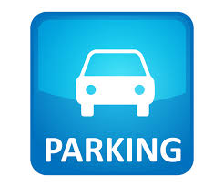

**PARKING:**

Please only park in the SRES designated parking spaces when visiting the school and not the YMCA parking spaces. Parking in the YMCA spaces prevents their members from accessing their parking lot. Exits, entrances, and fire lanes should always remain open for emergency vehicles. Double parking is prohibited during school hours unless it is during arrival and dismissal; however please leave an open lane in the middle for emergencies. Parking at Southeast Raleigh Elementary School’s campus is very limited. Southeast Raleigh parents should park in our designated parking lot which is located directly in front of the carpool loop, on the far end of the building. It also extends to the back 2nd parking lot. The parking lot directly in front of the swimming pool is designated for YMCA members only.

**PTA:**

Our PTA is the school support as well as home support. We work together to meet the needs of our families. We request that all families, if able, join the PTA and support its advocacy efforts that positively impact the school.

**STUDENT ARRIVAL:**

The instructional school day begins at 8:30 AM weekdays. Students should be dropped-off quickly once safety patrol and/or adults are ready to receive students. Our doors will open daily at 8:00 AM - no sooner. Students that arrive after 8:30 AM are tardy and must be signed-in at the main office by an adult. **You must show your ID to also sign your child in.** Try to schedule all non-emergency doctor and dentist appointments for after school hours. If your child must arrive late to school, an adult must accompany the student into the main office to sign-in and show their ID in order to enter the school building.

Students arrive in one of two locations: The carpool loop or the bus loop entrance. All bus or carpool students will enter the building through the bus loop door entrance. The bus loop doors will CLOSE at 8:30 AM, so any students who are tardy, will need to enter through the front of the school through the double doors.. Students who arrive after the tardy bell MUST be signed into school by their supervising adult. Students eating breakfast should go directly to the cafeteria as breakfast hours are between 8:00am -8:30am. Students should avoid restrooms or visiting other classrooms before going to his/her classroom. As part of our school safety plan, no parent or adult will be allowed to walk students to class. Again, this is for school safety. No visitors/guardians are allowed to drop-in to see their child’s teacher during arrival or during the school day unless an appointment was pre-scheduled.

**PreK ARRIVAL**

Arrival and dismissal procedures enhance and ensure the safety of all PreK children coming in and out of SRES. It is important that families understand and follow these procedures as it not only ensures the safety of their children but also ensures the smooth operation of the elementary school arrival and dismissal procedures as well. **Parking is not permitted in the front lot where buses and childcare vans are arriving and departing between 8-8:30am and 3-3:30pm**. **Parking is additionally never permitted in the YMCA lot unless families are utilizing YMCA facilities.**

1. SRES school carpool line runs from 8-8:30am for the elementary school. *If your preschooler has an elementary sibling*, you may drop off all children together through the carpool line during this timeframe.
2. If your child does not come through the elementary carpool with a sibling (or ride a bus), then you would need to **park in the back lot** (*not the YMCA lot & not front lot- as this becomes the bus lane*) and walk your child to their exterior classroom door where they will be greeted directly by a teacher or staff member, and you will sign them in.

**STUDENT DISMISSAL**:

The school day ends at 3:00 PM. If your child must leave school early, write a note or email the teacher stating what time your child will be picked up and who will be picking him/her up. Students will be dismissed in one of two locations: the main exit or the bus loop exit. The main exit for dismissal is for students in vehicles being picked up at specific areas. The bus loop exit is for students who are walkers, bikers, or bus riders. Students will not be dismissed from the office after 2:30 PM. If it is after 2:30 PM you will be asked to wait and utilize regular dismissal procedures beginning at 3:00. Parents may not pick-up a student or students early just to beat the carpool line. Early pickups deprive the student of a full day’s activities and become classroom disruptions. (There is No guarantee that teachers will be able to see a text message to change mode of transportation.

**PreK DISMISSAL**

1. SRES elementary carpool line and bus lane runs from 3-3:30. You must have a carpool tag from the front office if you are picking up in carpool.
2. Students will have a transportation tag on their bookbag that indicates their mode of transportation.
3. If you do not use the elementary carpool line or have a bus rider, then classroom door pick up will run from individual exterior classroom doors from **2:30- 3:00**. **Please park in the back lot** (*not YMCA lot or front lot as this becomes the bus lane)* and be prepared to show your ID for your child to be released to you upon sign out.

In order to avoid a late pickup, please arrive in the carpool line for pickup between 2:30-3pm as the carpool lane gets backed up and you will potentially get stuck in that traffic and unable to pick up your child time if you are picking up at the door.

**STUDENT DRESS/UNIFORMS:**

Southeast Raleigh Elementary School is committed to our student’s school experience and we want to eliminate barriers that often prevent students from succeeding in school. School uniforms have a transforming impact on student attitudes and academic environments. It eliminates peer pressure and competition and fosters equity among diverse student populations. Uniforms help increase school spirit, but most importantly, it saves families money and promotes a unified school community.

At SRES, all students will wear their school uniforms Monday through Thursday and we will have Free Expression on Fridays. This means students will be allowed to wear WCPSS dress code appropriate outfits of their choice on Fridays only.

Please see the detailed uniform selection by grade levels below.

|  |  |
| --- | --- |
| K-4th Grade SRES Students | 5th Grade SRES Students |
| All SRES K-4th grade students are asked to wear purple or white-collar shirts Monday - Thursday partnered with khaki-colored bottoms (pants, shorts, jumpers, skirts).  SRES students are asked to wear top sliders, tennis shoes, and/or sandals. No flip flops, slides or sandals without straps are permitted. Please keep in mind when determining shoe choices that students will participate in physical activity, daily. | All SRES 5th grade students are asked to wear hunter green or white-collar shirts Monday - Thursday partnered with khaki bottoms pants, shorts, skirt).  SRES students are asked to wear top sliders, tennis shoes, and/or sandals. No flip flops, slides or sandals without straps are permitted. Please keep in mind when determining shoe choices that students will participate in physical activity, daily. |

Please select this [link](http://raleigh.educationaloutfitters.com/find-my-school/southeast-raleigh-elementary/) to order your polo uniform.

Free Expression Friday- Parents/guardians are asked to use good judgment with regard to proper school dress for students. NO short shorts (shorts must be to the student’s fingertips), bare midriffs (boys and girls), spaghetti straps, halter tops or other distracting clothing. These clothing items are NOT considered acceptable attire. Clothing that contains any offensive symbols or words are also not allowed. Students will be expected to keep their pants pulled to their waist and hats and other headgear may not be worn in the building unless permitted by administration. Tennis shoes should be worn on days when students have PE and are most appropriate for structured play. These guidelines are designed to help provide an instructional atmosphere and assist with security measures. For more information, please review WCPSS Dress Code in the WCPSS Student/Parent Handbook.

**STUDENT HEALTH AND SAFETY:**

At the elementary level in Wake County, students are not permitted to “self-medicate.” Medication will be administered to students with the proper documentation (Form 1702) on file, signed by the parent and physician, as is required by WCPSS Policy. Parents/guardians who wish to administer medication to their child during the school day may do so. Please report to the main office during these occasions.

School personnel will notify parents and arrange for children to go home when they have the following symptoms:

* Fever of 100 or higher (child should remain at home until fever free for 24 hours without fever reducing medication)
* Nausea, vomiting, diarrhea (child should remain at home until free of symptoms for 12 hours)
* Severe headache
* Red, watery eyes with drainage
* Undiagnosed rash The school health room serves as a temporary resting place for sick children and the location to administer first aid for minor injuries.

Parents will be called to pick up a child if he/she is unable to return to class. If your child is injured at school, school personnel will administer basic first aid and contact you concerning any injury more serious than a minor abrasion.

If an emergency requires immediate attention, we will contact 911 and then contact the parent. All students entering school for the first time are required to have a complete physical examination and up-to-date immunizations to be placed on file at school. All health records must be in compliance within the first 30 days of school. Students without completed records are required to be suspended from school until the requirements are met. Please contact our Data Manager, Leann White at 919-694-8444, if you have any questions or need additional information.



**STUDENT WELLNESS:**

WCPSS Board Policy 6140 states the student wellness policy. Students at Southeast Raleigh Elementary will adhere to it. This policy allows for all students to receive at least 30 minutes of physical activity every day. The removal of recess will not be used as punishment.



**TELEPHONE MESSAGES:**

Parents/guardians are asked to make after school arrangements with their children before they leave home. Permanent changes in transportation should be in writing and submitted to your child’s teacher. Messages for students will be delivered at the end of the instructional day in order to protect instructional time. Messages for teachers will be placed in their mailboxes. Phone calls will be returned within 48 hours. However, the best way to reach a teacher is by email.

**TRANSPORTATION CHANGES:**

All temporary transportation changes must be communicated to the main office. Last minute and/or emergency changes must be made to the main office before 2:30 PM. Please refrain from calling after 2:30 PM to make transportation changes as it will disrupt the dismissal procedures for the entire school. Any time a student’s transportation home changes from his/her regular routine, the main office must receive a written note from the parent. Staff are directed to send students home their regular way unless a note is presented. Please note that a verbal request from the child to change transportation home will not be honored.

TRANSPORTATION (Bus and Cab Rider Code of Conduct)

We have developed a bus and cab rider code of conduct that supports a safe and orderly ride to and from school. It empowers and supports drivers to address inappropriate student behavior. Please see the expectations below:

**Rider Expectations**

District-provided transportation is offered to eligible riders.

* Sit in your assigned seat
* Keep your hands to yourself
* Use a quiet talking voice
* Remain seated
* Follow driver’s instructions
* Arrive at the bus stop 10 minutes prior to the stop time
* Wait at the bus stop in an orderly manner in a safe location
* Follow loading, crossing rules, and procedures
* Do not bring inappropriate items on the bus or cab
* No hitting and no fighting
* Be totally silent at railroad crossings
* Keep the bus or cab clean

**WALKERS:**

Walkers enter the building through the bus loop at 8:00am. Please be reminded that the tardy bell rings at 8:30am. Students who arrive after 8:30 am must be accompanied by an adult to the main office. If needed, please contact the YMCA for before school care.

**Walker Pick Up:**

A walker permission form must be completed by parent/guardian and be on file at the school for students to be deemed a “walker”. Students will be given a purple walker tag that will indicate that students are allowed to walk home. Tags will have the student's name, be laminated, and zipped tied to the student's backpack. Please see the main office for a permission form. Students who are escorted home by parents should be picked up at the exterior media center door.

**WHAT TO BRING/WHAT NOT TO BRING TO SCHOOL:**

Students should be prepared each day with paper, pencils and other school supplies. Any money brought to school i.e., lunch money, picture money and book money, should be in a sealed envelope with the child’s name and the teacher’s name on the front. Students should not bring extra money to school. Students may NOT bring cell phones, toys, radios, hand-held games, Pokémon cards or athletic equipment to school. The school is not responsible for lost or damaged personal items. If items that are not allowed on campus are made visible, they will be confiscated by administration. Items will be released to parents/guardians only. To protect our building and furniture, chewing gum is also not allowed.

**WCPSS CODE OF STUDENT CONDUCT:**

All students are responsible for complying with and are expected to be familiar with WCPSS Code of Student Conduct and school board policies governing student behavior and conduct (Code 4309). All Code of Student Conduct policies are contained in the WCPSS Student/Parent Handbook, which is distributed to all students and parents at the beginning of each school year or upon enrollment in a WCPSS school. If there is a conflict between the rules expressed in this handbook/agenda/planner and the Code of Student Conduct policies, the WCPSS Code of Student conduct policies shall take precedence. Please keep in mind that our first priority is student safety. Students are not permitted off campus without staff supervision during instructional time. Please discuss the importance of your child keeping themselves and others safe during school hours.

